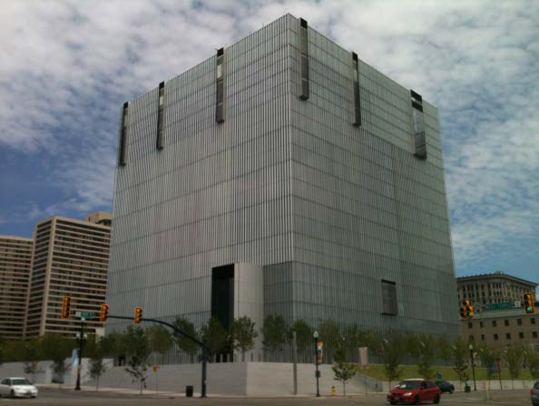

Courthouse Information:

351 South West Temple
Salt Lake City, UT 84101

Main Number: (801) 524-6100

Tours are scheduled BY APPOINTMENT ONLY – please submit this form at least 1 month in advance of proposed visit.

Register for your tour of the United States Courthouse for the District of Utah by completing this form and emailing it to outreach at: utddb_outreach@utd.uscourts.gov

This form is in “Outreach & Education” on our website at www.utd.uscourts.gov

Requestor’s name

Organization (school name, civic group, etc.):

Phone number Date Requested

Email

# of attendees in your group (no more than 40)

Interests/studies/reason for visit

Subject to staff availability, the court tour may consist of some or all of the following:

- Tour of Courthouse
- Speakers from the Clerk's Office, Chambers or Pretrial & Probation Services
- Observe a live court hearing
- Presentation by a Judge
- Question and Answer Session
- Mock Trials
- Separate arrangements can be made for groups interested in observing or participating in the Naturalization Ceremony (1 to 1.5 hours) – see calendar on our website

College students? If you are interested in attending a session of court, please see the court calendars that are posted on our website and contact the Clerk's Office at 801-524- 6100 with any questions.

Outreach Coordinator:
Noemi Torres
801-524-6285 Revised 9-7-22

