- Startup
1
System Startup: This screen indicates the audio/video system is powered off. The Lectern touch panel cannot turn the system on or off. System power must be controlled from the CRD or Judge touch panel.

When activated from the Judge or CRD touch panel the control system will power on and show a countdown page indicating remaining time until it is ready to use ( ). The touch panel will then show the “Main Menu” (see Section II: Main Menu).
2

1

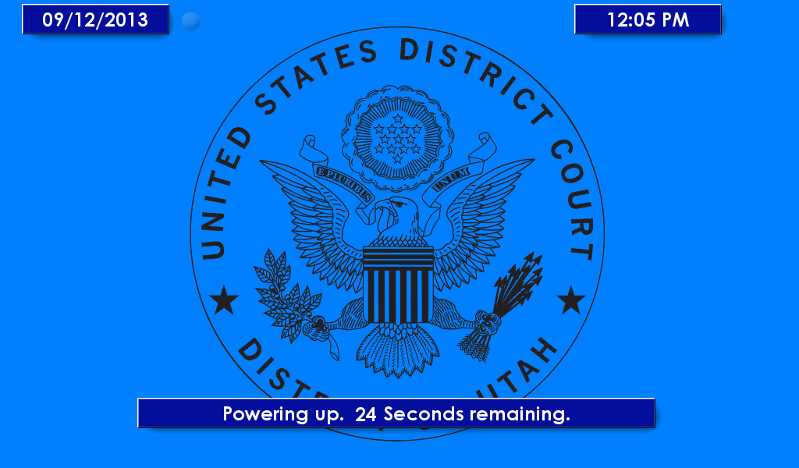
2

- Main Menu

These controls are visible on every page.
1
Evidence Volume Control: Controls for the currently selected evidence media source volume.
2
Video Source Selection: Press to display one of the lectern or media cart video sources on the courtroom monitors.
3
Video Source Controls: Opens a subpage with controls specific to the indicated video source device. (see Section III: Video Source Controls).
4
Help: Displays an overlay with helpful information for operating the page that is currently open.

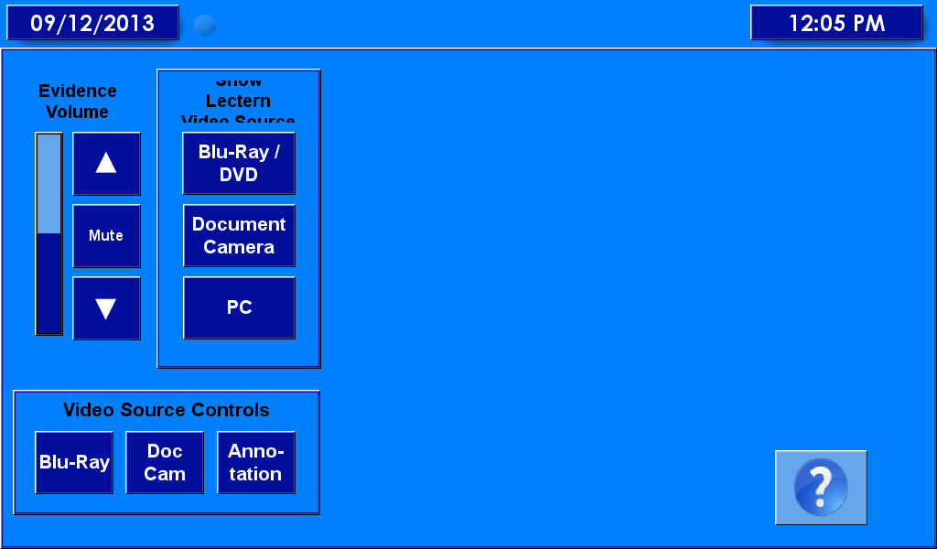
4
3
2
1

- Video Source Controls
1
Blu-Ray Controls: This page contains general transport controls for the playback of a Blu-Ray or DVD Video( ) and controls to navigate the on-screen menus ( ) for the Blu-Ray player located in the Media Cart.
2
1a
1b
Document Camera Controls Page: This page contains controls for the Document Camera including Power ( ), Zoom ( ), Focus ( ), and lamps power ( ).
3
2d
2c
2b
2a
Annotation Controls: This page contains controls for the on-screen video annotation device. Here the color can be selected ( ), line width can be changed ( ), and the pointer shape can be selected, disabled, or enabled ( ).
3c
3b
3a

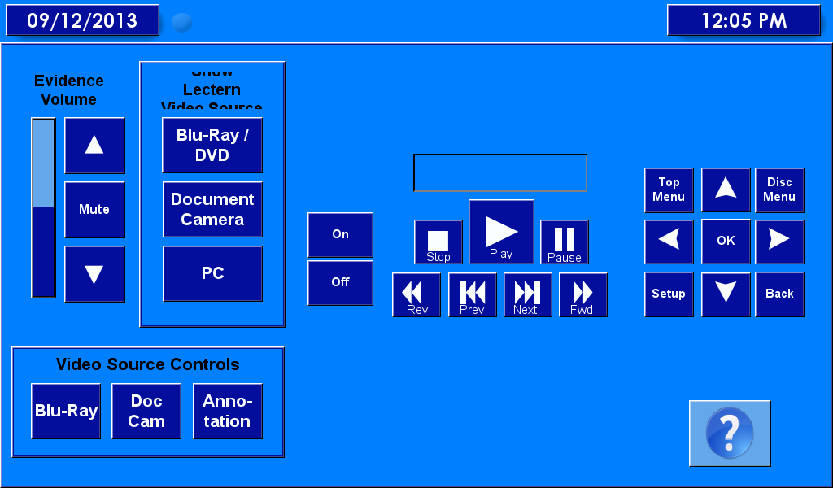
1
1b
1a

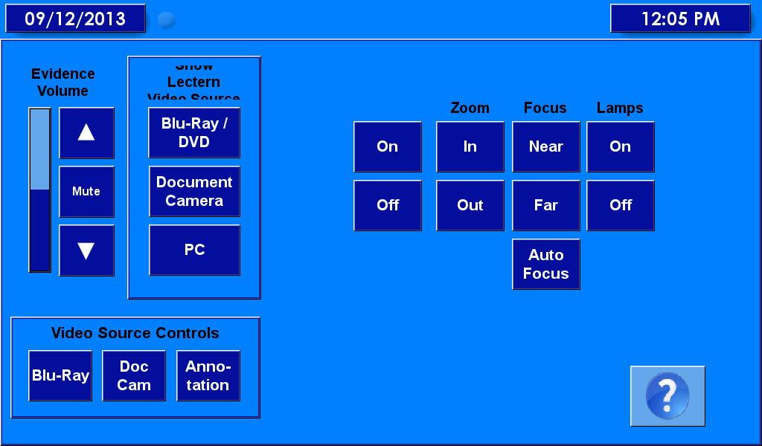
2d
2c
2b
2a

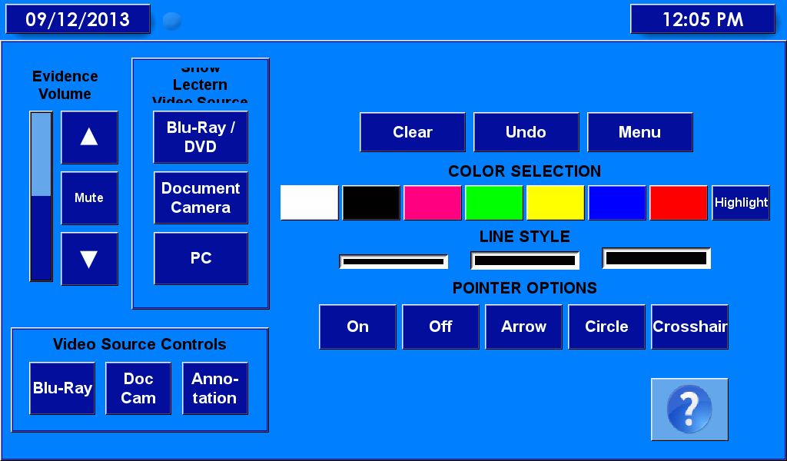
3c
3b
3a

